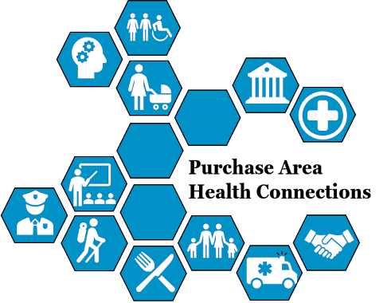
Purchase Area Health Connections is a network of partners dedicated to improving the health and well-being of individuals in the Purchase Area. Health coalitions are an important facet of Purchase Area Health Connections. While many coalitions focus on the health needs of their respective counties, there are also region-wide coalitions focused on the Purchase Area as a whole

Region-Wide Coalitions _____________________________

Purchase Area Health Connections
- TBD
- Network Director: Kaitlyn Krolikowski; kkrolikowski@purchasehealth.org

Opioid Taskforce
- Mission: To prevent substance use disorder, expand treatment and recovery services including workforce integration, and to reduce harm and stigma in the Purchase Area.
- Third Friday of the month at 11:00am
- Meet via Zoom
- Chair: Kaitlyn Krolikowski; kkrolikowski@purchasehealth.org

West Kentucky Mental Health Workgroup
- Mission: To create a positive conversation around mental health and to improve the mental well-being of the people in all areas of our community through education, advocacy, and support across all ages and groups.
- Fourth Monday of the month at 12:00pm
- In-person; locations rotate counties each month
- Co-Chairs:
  - Shay Glover; sglover@mcphd.org
  - Courtney Williams; courtney.gcasap@gmail.com

Purchase Area Diabetes Connection
- A coalition of health professionals and community members whose goal is to increase diabetes awareness and promote Diabetes Self-Management Education and Support and Diabetes Prevention Programs. Our vision is to reduce the burden of diabetes in our community. This group puts on the Purchase Area Health Expo each fall.
- Third Wednesday of the month at 2:00pm
- Meet via Zoom or conference call
- Chair: Deanna Leonard; dleonard@purchaseheatlh.org

Four Rivers Regional ASAP Connection
- A coalition of county ASAP leaders and key stakeholders within the region who meet for collaboration purposes and to increase knowledge of resources within the region.
- Quarterly meetings via Zoom.
- Chair: Brooke Lodge, clodge@4rbh.org

County-Wide ASAPs
- Kentucky ASAPs were created in 2000 to develop a strategic plan to reduce the prevalence of alcohol, tobacco and other drug use among youth and adult populations in Kentucky and coordinate efforts among state and local agencies in the area of substance abuse prevention. Each county in the Purchase Area has its own county-specific ASAP coalition, detailed below.

Ballard County ___________________________________
Ballard County ASAP
- Fridays at 9:00am, contact Chair for dates.
- In-person at Ballard County Health Department
- Chair: Kelly Wray; kelly.wray@ballard.kyschools.us

Calloway County _____
Calloway County ASAP
- Third Monday of the month at 12:00pm
- In-person at Pagliai's in Murray
- Chair: TBD

Carlisle County ______________________________
Carlisle County ASAP
- Every other second or third Tuesday at 9:00am
- Meeting via Zoom
- Chair: Allison Rogers; allison.rogers@carlisle.kyschools.us

Fulton/Hickman Counties ________________________
Fulton/Hickman Counties ASAP
- Every other month, usually Thursday at 2:00 P.M.
- In-person at Clinton Methodist Church or Caycee Church
- Chair: Vickie Batts; vickie.batts@hickman.kyschools.us

Graves County ___________________________________
Graves County ASAP
- Second Thursday of the month at 2:00pm
- In-person at the Graves County Health Department (416 Central Ave, Mayfield KY)
- Chair: Courtney Williams; Courtney.gcasap@gmail.com

Get Fit Graves (Graves County Health Coalition)
- Mission: Improving the quality of life of Graves County residents by providing valuable accommodations and resources.
- 2nd Friday of almost every month at 1:00pm
- In-person at the Graves County Health Department (416 Central Ave, Mayfield KY)
- Chair: Riley Beth Willet, RileyE.Willett@graveshealth.org

Livingston County ____________________________________
Livingston County Health Alliance (LCL)
- Mission: to improve the health of residents in the tri-county area, through expanding healthcare access, coordinating, and improving the quality of healthcare for residents in the service area.
- Scheduled by meeting
- In-person at Salem Baptist Church
- Chair: Amy Ramage; amy.ramage@livingston.kyschools.us

Marshall County ________________________________
Marshall County ASAP
- Third Tuesday of the month at 1:30pm
- Meeting via Zoom
- Chair: Jenny Griffin; jgriffin@mcphd.org

Marshall County Health Coalition
- Mission: Together we strive to improve the health and well-being of Marshall County by providing valuable services through community collaboration.
- Quarterly meetings (2023 dates: April 11, July 18, October 10) at 10am
- In-person at CFSB in Benton (221 W 5th St, Benton, KY 42025)
- Chair: Shay Glover; sglover@mcphd.org

McCracken County ____________________________________
McCracken County ASAP
- Second Tuesday of the month at 9:00am
- Meeting via Zoom (quarterly meetings in-person)
- Chair: Brandon Fitch; bfitch@4rbh.org

Healthy Paducah
- A coalition of community members, health care providers, social services, businesses, faith based organizations, and various other members devoted to sharing resources and information to help improve the wellness of citizens in Paducah.
- Last Monday of the month at 9:00am
- Meeting via Zoom
- Chair: Mike Muscarella; Mmuscarella@BHSI.com

